Project Design

Group 4

2017/02/15

# Storyboard: Front Page

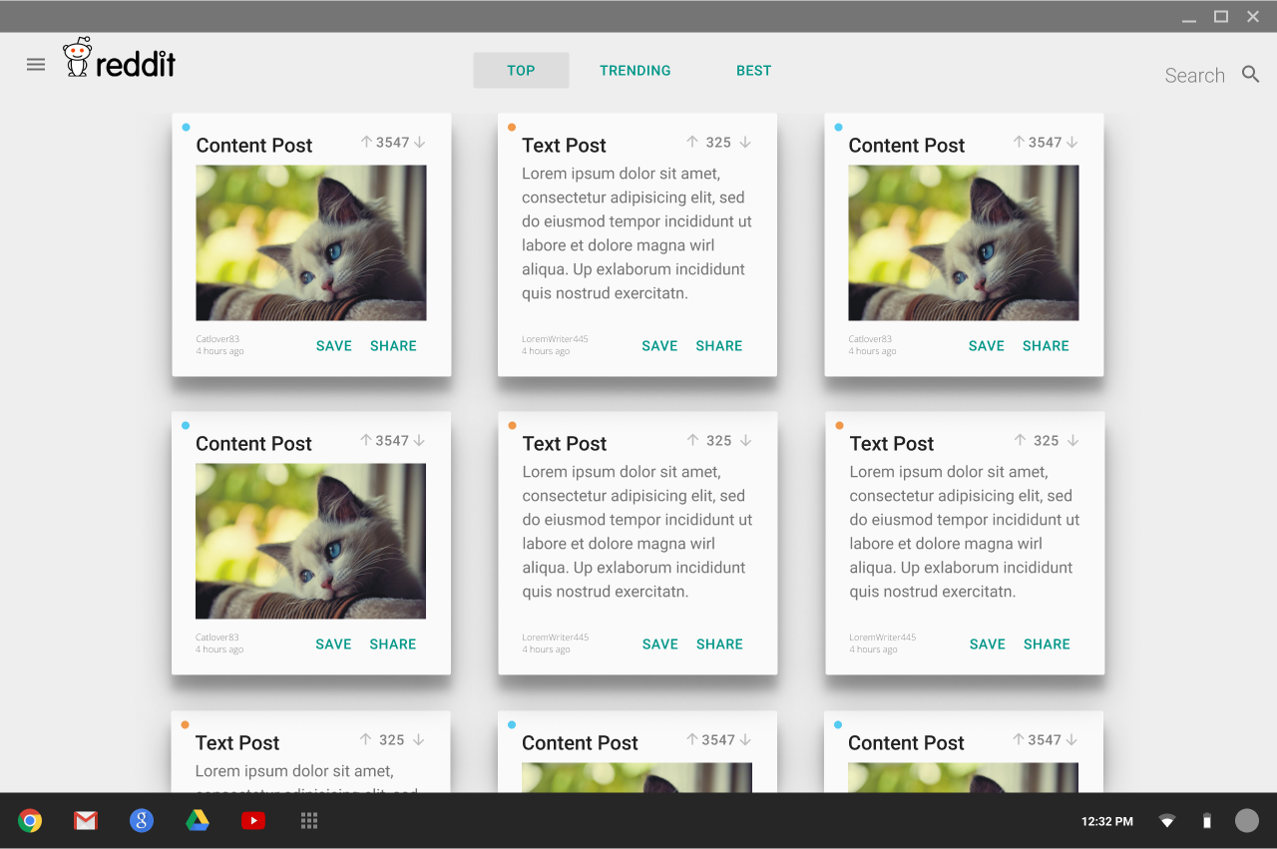

## Front Page

|  |  |
| --- | --- |
| Artifact | Usage |
| Logo | If you click logo, you will redirect to the home page. |
| Nav-bar guide button | If the user clicks the guide button, the toolbar appears. |
| Date and Time | If you click date and time, the post date and time appears. |
| Author | If you click author, a new page with author’s profile appears. |
| Post | If you click on a Post, a new tab with the content appears. |
| Content Title | If you click content title, a new tab with the content appears. |
| Save | If the user clicks on the save icon, the Post gets saved to the Saved pages section. |
| Share | If the user clicks on the share icon, sharing options are made available. |
| Upvote | If you click upvotes, the number of vote will increase. |
| Downvote | If you click downvotes, the number of vote will decrease. |
| Top | One of the three buttons in the top of the front page, so when users click on it, it would take them to the top videos of the day. |
| Trending | One of the three buttons in the top of the front page, so when users click on it, it would take them to the most popular videos on Reddit. |
| Best | One of the three buttons in the top of the front page, so if you click on Best, the content of the Posts section is replaced with the ‘Best’ posts of all time. |

# Storyboard: Search

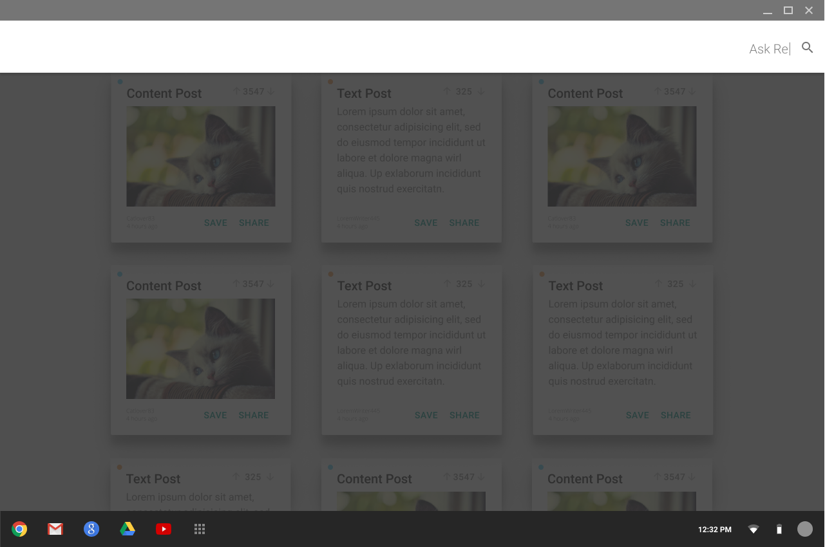

|  |  |
| --- | --- |
| Artifact | Usage |
| Search Bar | When the user clicks the search bar, the content portion of the page darkens and the search bar slightly increases in size. |
| Search Bar Textbox | If you click in the search textbox, input a search term and hit enter, you can search the Reddit site for content. The results will appear in the content section. |

# Storyboard: Navigation Bar

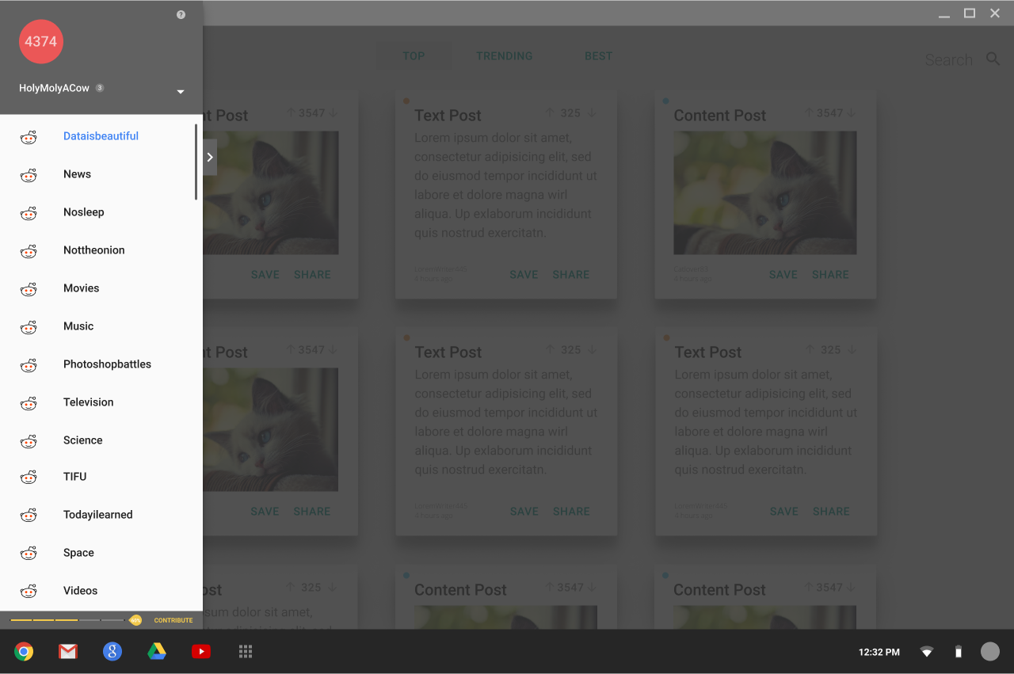

## Navigation Bar

The Navigation bar displays user information, saved pages, preferences, and it provides links to favorited Subreddits.

### Top of Navigation Bar

|  |  |
| --- | --- |
| Artifacts | Usage |
| Karma icon | If you click karma icon, nothing happens. |
| Daily Reddit Gold Goal | Displays the daily donations total and the amount the user has contributed. |
| Username | If you click on the username a new tab opens displaying user activity information. |
| Vertical Caret | If the user clicks on the vertical caret icon, a dropdown menu is displayed with a Preferences option and a Saved option. If the user clicks outside the dropdown the menu disappears. |
| Preferences | If the user clicks on Preferences, the content of the page is changed to the user’s preferences page. |
| Saved | If the user clicks on Save, the content of the page is changed to the users saved page. |

### Middle of Navigation Bar

|  |  |
| --- | --- |
| Artifacts | Usage |
| My Subreddits list | It is the list that contains the topics that the user prefer if he/she is a registered user. Also it would be the list that contains default topics if the user is unregistered. |
| Pull-Out Tab (Right Caret) | If the user clicks on the Pull-Out Tab icon, a panel appears to the right of the toolbar allowing the user to add Subreddits to the subreddit list. If the user clicks outside the toolbar area the panel disappears |
| Hide toolbar | If the user clicks outside of the toolbar the toolbar disappears. |
| Extension icon | If you click extension icon, you will browse all types of topics in the Subreddits list. |

### Bottom of Navigation Bar

|  |  |
| --- | --- |
| Artifacts | Usage |
| Contribute & Gold Coin | If the user clicks on Contribute or the gold coin, a new tab opens to the donation page. |
| Daily Reddit Gold Goal | Displays the daily donations total and the amount the user has contributed. |

# Storyboard: Subreddit Selection

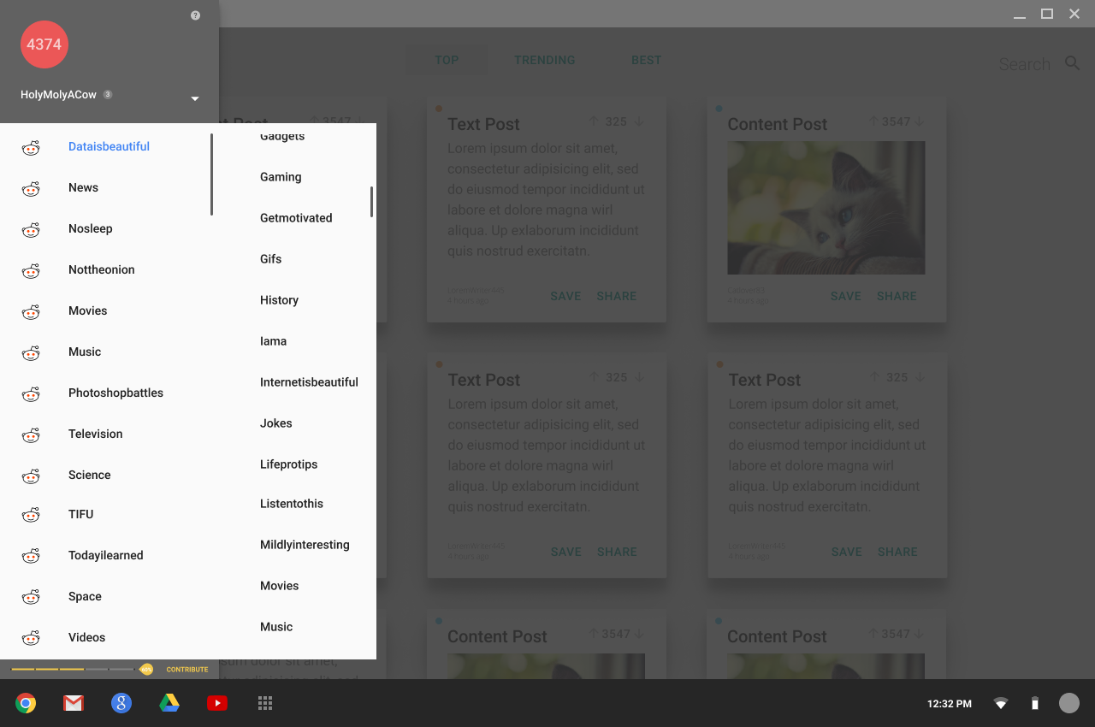

## Subreddit Selection Panel

This Panel lists the available Subreddits in a list. It has a vertical scroll bar.

### Vertically Scrolling Panel

|  |  |
| --- | --- |
| Artifacts | Usage |
| Subreddit Entry | If the user clicks on a subreddit entry, the subreddit gets added to the users My Subreddit List. |
| Hide panel | If the user clicks outside of the panel it disappears. |